**INSTITUTE OF ENGINEERING**

ADVANCED COLLEGE OF ENGINEERING AND MANAGEMENT

KALANKI, KATHMANDU

(AFFILIATED TO TRIBHUVAN UNIVERSITY)



**LAB REPORT**

**SUBJECT: INTERNET & INTRANET**

**LAB NO: 01**

**SUBMITTED BY:** **SUBMITTED TO:**

NAME: DIPESH DHUNGANA DEPARTMENT OF COMPUTER

ROLL NO: ACE077BCT035 AND ELECTRONICS

DATE: DECEMBER 13, 2024

**TITLE**: WEB PROGRAMMING SKILLS (HTML/CSS)

**OBJECTIVE**:

TO CREATE A BASIC REGISTRATION FORM USING HTML AND CSS

**THEORY**:

HTML (HyperText Markup Language) is the standard language used to create and structure web pages. It uses simple tags to define elements like headings, paragraphs, images, links, and forms. Each element is written with a start tag (e.g., <p>) and an optional end tag (e.g., </p>), enclosing the content. HTML is the foundation of all web pages, providing the basic framework that browsers use to display text, images, and other media on the internet.

CSS (Cascading Style Sheets) is a language used to style and design web pages. It controls the appearance of HTML elements, such as colors, fonts, layouts, and spacing, making websites more visually appealing. CSS works by applying rules to HTML elements using selectors and properties. For example, it can change the background color of a page, adjust text size, or create responsive layouts for different screen sizes. By separating content (HTML) from design (CSS), it allows for easier customization and consistency across web pages.

A form is created using the <form> tag, with the action attribute defining the destination for submitted data and the method attribute specifying the submission type, such as GET or POST. Input fields like text boxes, date selectors, and number fields are added using <input> tags, each having unique id and name attributes for identification. The <label> tag is used to associate descriptive text with inputs, enhancing accessibility. Buttons such as submit and reset are included to enable interaction. The layout is structured using tables or CSS for alignment and readability, while styles like padding, border-radius, and box-shadow improve the visual appeal.

JavaScript can be used to dynamically extract and display user-submitted data. The object is employed to parse the query string from the URL, retrieving the values entered in the form fields. These values are then assigned to specific elements within the results table using the ‘textContent’ property. This process allows the data submitted through the form to be displayed automatically on the results page, ensuring a seamless transition and dynamic user experience.

**SOURCE CODE**

1. **lab1.html**

<!DOCTYPE html>

<html lang="en">

<head>

<meta charset="UTF-8">

<meta name="viewport" content="width=device-width, initial-scale=1.0">

<meta http-equiv="X-UA-Compatible" content="ie=edge">

<title>Registration Form</title>

<link rel="stylesheet" href="lab1.css">

</head>

<body>

<header>

<h1>Registration Form</h1>

</header>

<main>

<section>

<h2>Personal Information</h2>

<form action="lab1result.html" method="GET">

<div class="form-group">

<label for="name">Name:</label>

<input type="text" id="name" name="name" placeholder="Enter your name" required>

</div>

<div class="form-group">

<label for="rollnumber">Roll Number:</label>

<input type="text" id="rollnumber" name="rollnumber" placeholder="Enter roll number" required>

</div>

<div class="form-group">

<label for="dob">Date of Birth:</label>

<input type="date" id="dob" name="dob" required>

</div>

<div class="form-group">

<label for="mobile">Mobile Number:</label>

<input type="tel" id="mobile" name="mobile" placeholder="Enter mobile number" required>

</div>

<div class="form-group">

<label for="faculty">Faculty:</label>

<input type="text" id="faculty" name="faculty" placeholder="Enter faculty name" required>

</div>

<div class="form-group">

<label for="hobby">Hobby:</label>

<input type="text" id="hobby" name="hobby" placeholder="Enter your hobby" required>

</div>

<div class="form-actions">

<button type="submit">Submit</button>

<button type="reset" class="reset-btn">Reset</button>

</div>

</form>

</section>

</main>

<footer>

<p>&copy;Dipesh Dhungana 2024. All Rights Reserved.</p>

</footer>

</body>

</html>

1. **lab1.css**

/* General Reset */

* {

margin: 0;

padding: 0;

box-sizing: border-box;

}

body {

font-family: 'Arial', sans-serif;

background: linear-gradient(to bottom, #8e9eab, #eef2f3);

color: #333;

display: flex;

flex-direction: column;

min-height: 100vh;

}

header {

background: #4CAF50;

color: #fff;

text-align: center;

padding: 20px;

font-size: 1.5em;

box-shadow: 0 4px 8px rgba(0, 0, 0, 0.1);

}

main {

flex-grow: 1;

display: flex;

justify-content: center;

align-items: center;

padding: 20px;

}

section {

background: #fff;

padding: 30px;

border-radius: 10px;

box-shadow: 0 8px 16px rgba(0, 0, 0, 0.2);

width: 100%;

max-width: 500px;

}

h2 {

margin-bottom: 20px;

color: #4CAF50;

text-align: center;

}

.form-group {

margin-bottom: 15px;

}

label {

display: block;

margin-bottom: 5px;

font-weight: bold;

}

input {

width: 100%;

padding: 10px;

font-size: 1rem;

border: 1px solid #ccc;

border-radius: 5px;

transition: border-color 0.3s;

}

input:focus {

border-color: #4CAF50;

outline: none;

}

.form-actions {

display: flex;

justify-content: space-between;

}

button {

padding: 10px 20px;

border: none;

border-radius: 5px;

cursor: pointer;

font-size: 1rem;

}

button[type="submit"] {

background: #4CAF50;

color: #fff;

}

button[type="submit"]:hover {

background: #45a049;

}

.reset-btn {

background: #f44336;

color: #fff;

}

.reset-btn:hover {

background: #e53935;

}

footer {

text-align: center;

background: #4CAF50;

color: #fff;

padding: 10px;

font-size: 0.9rem;

position: fixed;

width: 100%;

bottom: 0;

}

1. **lab1result.html**

<!DOCTYPE html>

<html lang="en">

<head>

<meta charset="UTF-8">

<meta name="viewport" content="width=device-width, initial-scale=1.0">

<meta http-equiv="X-UA-Compatible" content="ie=edge">

<title>Submitted Information</title>

<link rel="stylesheet" href="lab1result.css">

</head>

<body>

<header>

<h1>Submitted Information</h1>

</header>

<main>

<section>

<table>

<tr>

<td><strong>Name:</strong></td>

<td id="name"></td>

</tr>

<tr>

<td><strong>Roll Number:</strong></td>

<td id="rollnumber"></td>

</tr>

<tr>

<td><strong>Date of Birth:</strong></td>

<td id="dob"></td>

</tr>

<tr>

<td><strong>Mobile Number:</strong></td>

<td id="mobile"></td>

</tr>

<tr>

<td><strong>Faculty:</strong></td>

<td id="faculty"></td>

</tr>

<tr>

<td><strong>Hobby:</strong></td>

<td id="hobby"></td>

</tr>

</table>

</section>

</main>

<footer>

<p>&copy; 2024 Dipesh Dhungana. All Rights Reserved.</p>

</footer>

<script>

// Get data from the URL (query string)

const urlParams = new URLSearchParams(window.location.search);

// Display the form data in the table cells

document.getElementById("name").textContent = urlParams.get("name");

document.getElementById("rollnumber").textContent = urlParams.get("rollnumber");

document.getElementById("dob").textContent = urlParams.get("dob");

document.getElementById("mobile").textContent = urlParams.get("mobile");

document.getElementById("faculty").textContent = urlParams.get("faculty");

document.getElementById("hobby").textContent = urlParams.get("hobby");

</script>

</body>

</html>

1. **lab1result.css**

/* General Styles for the Body */

body {

font-family: Arial, sans-serif;

line-height: 1.6;

margin: 0;

padding: 0;

background-color: #f4f4f4;

}

/* Header Styling */

header {

background-color: #4CAF50;

color: white;

text-align: center;

padding: 20px;

}

/* Main Content Area */

main {

display: flex;

justify-content: center;

align-items: center;

height: 80vh;

padding: 20px;

}

/* Section Styling */

section {

background-color: #fff;

padding: 20px;

border-radius: 8px;

box-shadow: 0 4px 8px rgba(0, 0, 0, 0.1);

width: 100%;

max-width: 600px;

}

/* Table Styling */

table {

width: 100%;

margin-top: 20px;

border-collapse: collapse;

}

table td {

padding: 8px;

border-bottom: 1px solid #ddd;

}

table td:first-child {

font-weight: bold;

}

/* Footer Styling */

footer {

background-color: #4CAF50;

color: white;

text-align: center;

padding: 10px 0;

position: fixed;

bottom: 0;

width: 100%;

}

**OUTPUT (WEBPAGE SCREENSHOT)**

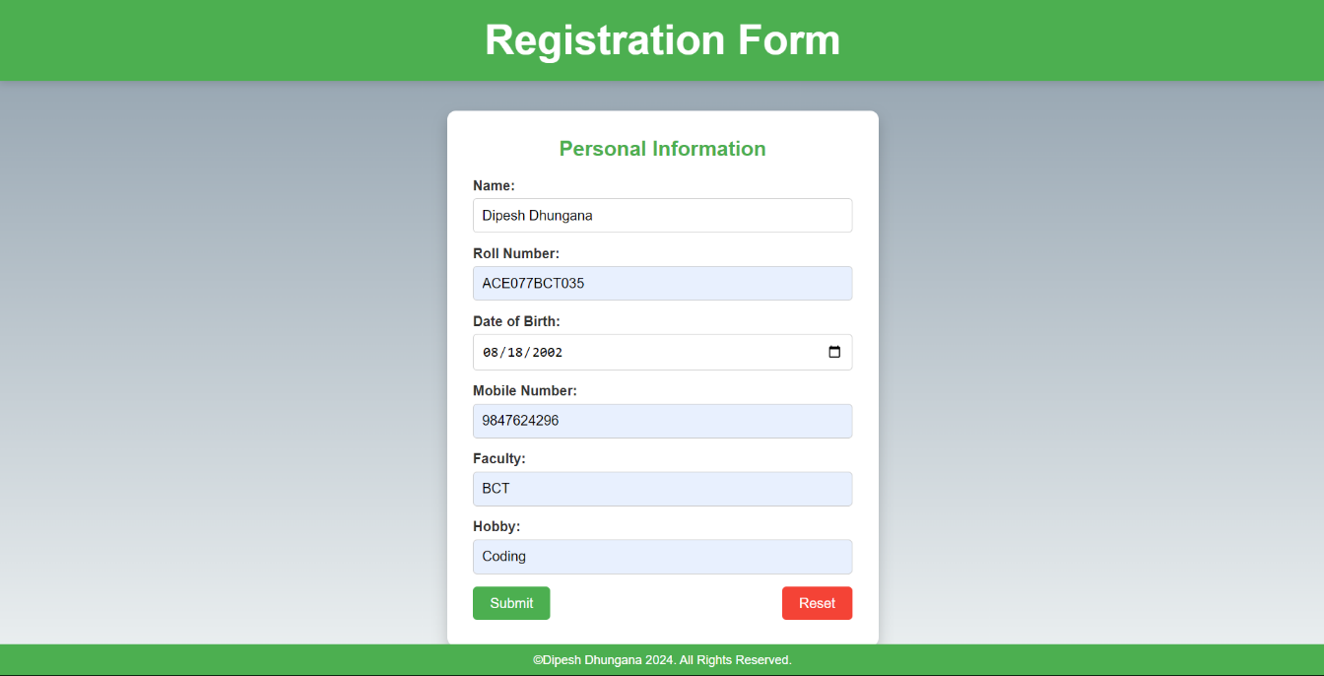

*(Registration Form Input)*

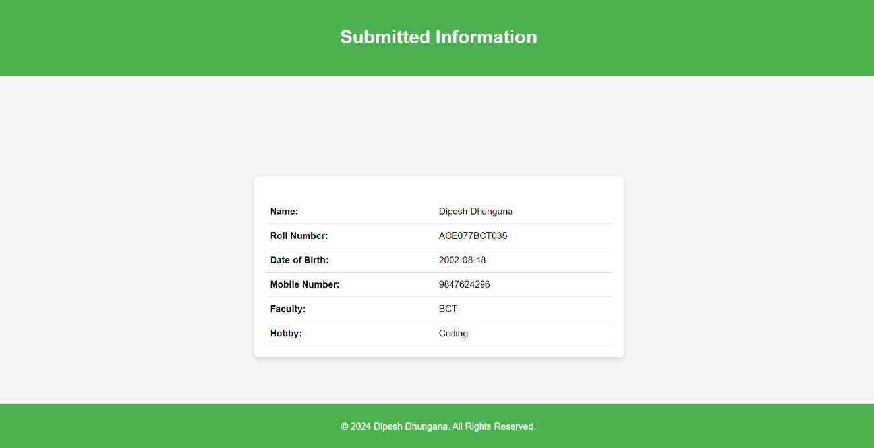

*(Display of Submitted Information)*

**DISCUSSION AND CONCLUSION**:

In this lab, we created a basic registration form using HTML and CSS. HTML was used to structure the form, which included various input fields like text boxes, date pickers, and buttons for submission and resetting. CSS was applied to style the form, enhancing its appearance with features like background gradients, padding, and responsive layout. The form's data is submitted via the GET method, and the submitted information is displayed dynamically on a results page using JavaScript. We used the <label> tags to improve accessibility, and CSS selectors to style the elements, making the form user-friendly and visually appealing.

This project helped us understand the importance of HTML for structuring web content and CSS for styling. By using simple HTML tags, we built a functional registration form, and CSS made it aesthetically pleasing. JavaScript enhanced the user experience by displaying submitted data without refreshing the page. Overall, this exercise reinforced the key concepts of web programming, such as form creation, data submission, and responsive design, while also emphasizing the separation of content (HTML) and style (CSS) for better maintainability.